CityChrone: an interactive platform for accessibility studies in urban systems. 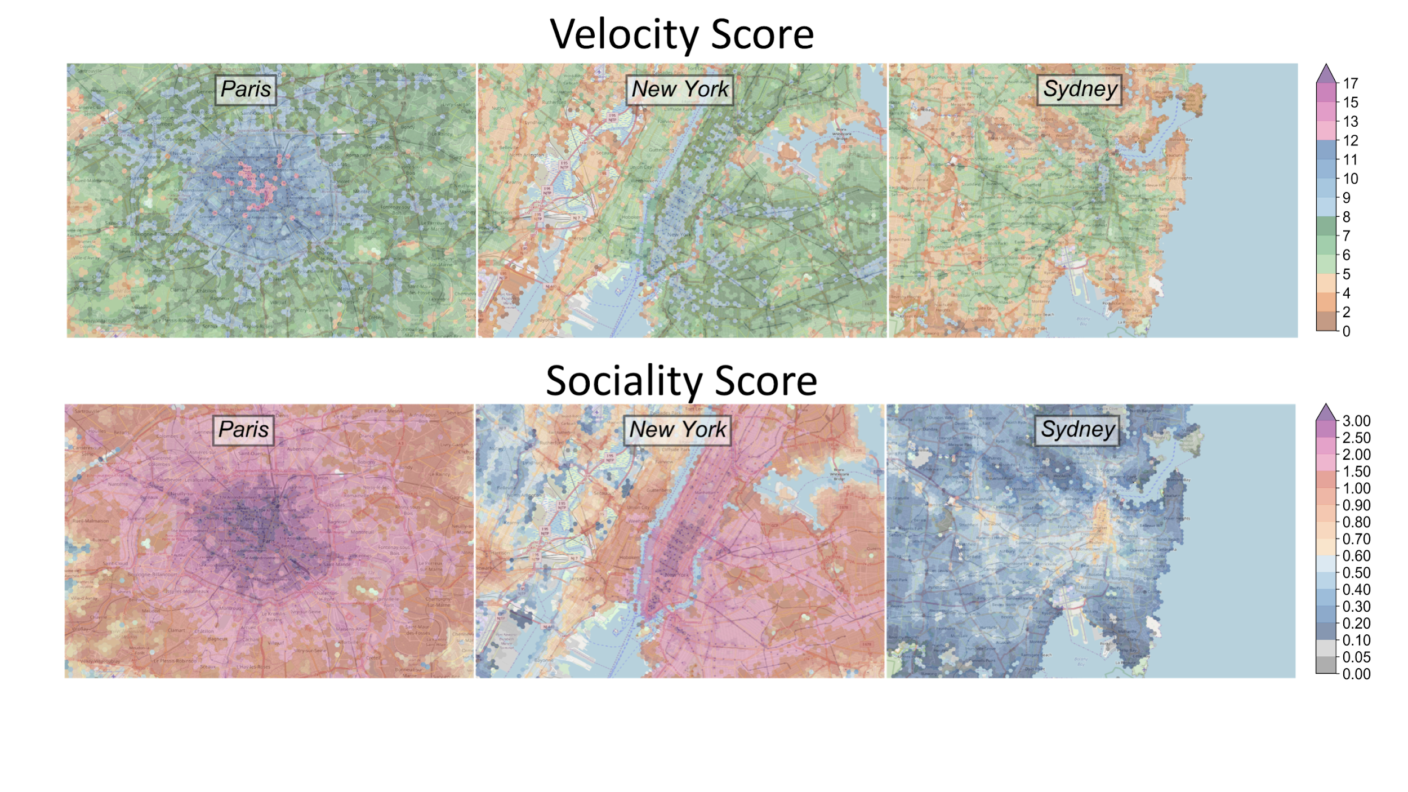

Indaco Biazzo -- DISAT/SmartData@polito - Politecnico di Torino

By the end of this century, most of the world population will be living in cities. The unprecedented level of urban interactions and interconnectedness represents a big challenge to scientists, urban planners, and stakeholders in order to describe, studies and manage cities. This situation calls for a big effort from the scientific community to come up with engaging and meaningful visualizations and friendly scenario simulation platform. We first consider a new perspective on how to evaluate accessibility in cities based on data of public transportation. By means of the notion of isochrones, coupled with the multi-layered nature of the public transport system and the spatial distribution of population density, we introduce punctual and comparable universal scores (Fig.1 and www.citychrone.org), mapping the accessibility of cities. Moreover, we rank cities according to their overall accessibility (Fig.2). Then studying the distribution of those accessibility measures we found great inequalities in the access to public transport services across the population of the same city. The striking similarities in the patterns observed in very different cities suggest the existence of a common mechanism and organization. We implement the citychrone platform [[www.citychrone.org](http://www.citychrone.org)], an open source, modular and scalable platform for urban planning and transports analysis. The platform allows to analyze and visualize accessibility quantities of public transports in cities by computing the travel time distance between a large set of points. Thanks to the high efficiency of the routing algorithm developed the platform allows users to create new public transports scenario and showing the effect on the mobility in a small time. All the source code of the CityChrone platform is open-source and only open data are used in order to ensure reproducibility of results.